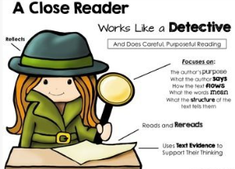
Close Reading Lessons Kindergarten
September
October | The following are videos and a piece of text to use for Close Reading. This is GREAT PLC work!  Video: How to do a Close Reading – Teach Like This (4:12) - https://www.youtube.com/watch?v=I_hhMeE7Osw  Video: Close Reading - Vocab Focus – (13:53) - http://www.youtube.com/watch?v=WgQYvj2U4Kw  Kindergarten text from LEAD21 Practice Companion – The Parade page 48
November | Here is a video of a teacher’s strategy for close reading. She uses a fiction text. The video is a little over 7 minutes long and would be great to watch as a PLC.  http://www.readwritethink.org/professional-development/strategy-guides/video/close-think-deeply-creating-30976.html  Attached is the article A Letter to Grandpa to use for close reading that connects to Unit 3 in LEAD21.
December | The following is a video of Grappling with Complex Fiction Through Close Reading:  http://vimeo.com/58540086 (6:40)  (Just a reminder viewing and discussing the video is great to use in a PLC.)  Close Reading text to accompany LEAD21 unit 4:  K – a poem Wind
January | Attached is a Power Point with questions for you to use when you are teaching a fiction close reading lesson. The questions are appropriate for your grade level and come from the standards.
February | Attached is a close reading and questions to go with each read. It goes with the book the Snowy Day by Erza Keats. Included is a typed copy of the words to the book if you want that for your students. Unit 5 is about celebrations and we would think that a snow day would definitely be a celebration for Kindergarteners.
March
April
May

